**Summer Internship Report**

**on**

**Automated Customer Services**

Submitted by

**Harshwardhan Jain (22CSU392)**

**Avishka Jindal (22CSU038)**

**Ujjwal Rao (22CSU293)**

DEPARTMENT OF COMPUTER SCIENCE AND ENGINEERING,

SCHOOL OF ENGINEERING AND TECHNOLOGY

THE NORTHCAP UNIVERSITY

GURUGRAM-122017

Internship Period: 03/06/2024 TO 12/07/2024

**Copy of Certificate of completion (issued by the industry you have done an internship)**



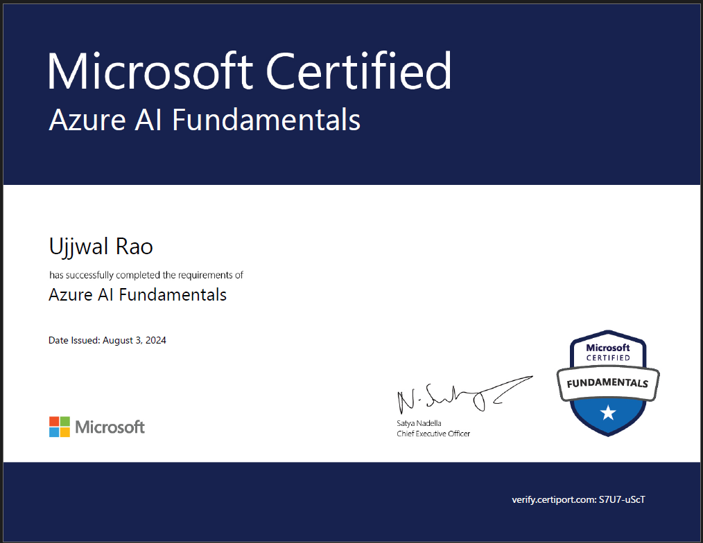

**TABLE OF CONTENTS**

**List of Tables**...………………………………………………………………………… 6

**List of Figures**…………………………………………………………………………. 7

**Abstract**...…………………………………………………………….……….……… 8

**1. Introduction**………………………………………………………………………… 9

1.1 Overview

1.2 Training Location

1.3 Focus Areas

**2. Problem Statement**………………………………………………………………... 10

2.1 Objective

2.2 Scope

**3. Social Relevance of the Project**…………………………………………………… 10

3.1 Impact on Industries

3.2 Benefits to Customers

3.3 Operational Efficiency

**4. Training Description**…………………………………………………………. 11 - 13

4.1 Project Goals

4.2 Methods Used

4.2.1 Custom Question Answering

4.2.2 Conversational Language Understanding

4.3 Stages of Training

4.3.1 Requirement Analysis and Planning

4.3.2 Design and Setup

4.3.3 Model Development

4.3.4 Testing and Validation

4.3.5 Deployment and Monitoring

4.4 Accomplishments

4.5 Technical Activities

4.6 Administrative Activities

**5. Experimental Results**………………………………………………………… 13 - 18

5.1 Custom Question Answering Service

5.2 Conversational Language Understanding

5.3 Bot Framework Emulator (V4)

**6. Analysis**………………………………………………………………………. 19 - 20

6.1 Technical Skills Acquired

6.2 Non-Technical Skills Acquired

6.3 Organizational Structure and Team Dynamics

6.4 Company Initiatives

6.5 Performance Analysis

6.6 Areas for Improvement

**7. Conclusion**……………………………………………………………………. 20 - 22

7.1 Advancement in Technical Understanding

7.2 Enhancement of Organizational Skills

7.3 Benefits Acquired from The Training

7.4 Enrichment of Knowledge

7.5 Areas for Further Improvement

7.6 Suggestions for Improvement of the Training Program

**8. Bibliography**…………………………………………………………………. 22 - 23

**9. Appendix**……………………………………………………………………… 23 - 26

9.1 Introduction to The Hosting Firm

9.2 Management and Administrative Structure

9.3 Sample Plans or Drawings

9.4 Technical Documents and Literature

9.5 Design and Calculation Sheets

9.6 Project Daily Task

**10. Project at a Glance**…………………………………………………………. 27 - 28

**LIST OF TABLES**

**1. Appendix**……………………………………………………………………… 23 - 26

Figure 9.6: Project Daily Task

**LIST OF FIGURES**

**Chapter 5. Experimental Results**………………………………………………. 13 - 18

**5.1 Custom Question Answering Service**……………………………………… 13 - 14

Figure 5.1.1: Empty Knowledge Base

Figure 5.1.2: Adding Sources in Knowledge Base

Figure 5.1.3: Editing and Testing Sources

**5.2 Conversational Language Understanding**………………………………… 14 - 15

Figure 5.2.1: Empty Schema

Figure 5.2.2: Adding Intents in the Schema

Figure 5.2.3: Training Model Part 1

Figure 5.2.4: Training Model Part 2

Figure 5.2.5: Model Performance Analysis

**5.3 Bot Framework Emulator (V4)** ………………………………………….... 16 - 18

Figure 5.3.1: Installing Dependencies for the Bot

Figure 5.3.2: Configuring Medical Bot

Figure 5.3.3: Done Finalizing the Medical Bot

Figure 5.3.4: Snapshot bot.js File

Figure 5.3.5: Snapshot of index.js File

Figure 5.3.6: Creating a Bot in Bot Framework Emulator

Figure 5.3.7: Saving Medical Bot File

Figure 5.3.8: Testing the Saved Bot Model

**Chapter 10. Project at a Glance**………………………………………………... 27 - 28

Figure 10.1: Final Snapshot of medicalbot.js File

Figure 10.2: Final Snapshot of index.js File

Figure 10.3: Executing the index.js File

Figure 10.4: Running the Bot Framework Emulator

Figure 10.5: Connecting the Saved Medical Bot

Figure 10.5: Testing the Live Medical Bot

**ABSTRACT**

My training took place at The NorthCap University, where I focused on preparation for the AI-900 MS Azure AI Fundamentals test. My primary training goals were to provide me with the skills and knowledge I needed to confidently pass the exam, which covered a wide range of artificial intelligence topics such as workloads and considerations, machine learning, computer vision, natural language processing (NLP), and conversational AI on Azure.

During the training, I engaged in various activities, such as:

* No-code Machine Learning with Azure ML Studio (AutoML and Designer)
* Analyzing images and text with Azure Computer Vision Service
* Classifying images and detecting objects with Azure Custom Vision Service
* Analyzing faces with Azure Face Service
* Analyzing receipts with Azure Form Recognizer Service
* Understanding language with Azure Language Understanding Services

My main accomplishment was passing the AI-900 exam with excellent grades. The most significant takeaways from this program included a thorough understanding of present AI applications and their possible future implications. Technically, I acquired hands-on experience with several Azure AI services, while non-technically, I learned how to manage projects efficiently and collaborate in a structured learning environment.

**1. INTRODUCTION**

My training was conducted at The NorthCap University, where I specialized in AI and machine learning. This training utilized Microsoft Azure, a leading cloud computing platform that supports the development, testing, and management of applications and services through Microsoft-managed data centers. Azure's robust AI and machine learning services provided a comprehensive toolset for building intelligent applications.

Throughout the training, I extensively used Azure's AI services, including Azure Machine Learning Studio for no-code and low-code model development, and Azure Cognitive Services for integrating AI capabilities into applications. I worked with Azure Computer Vision for image analysis, Azure Custom Vision for image classification and object detection, Azure Face for facial recognition, and Azure Form Recognizer for document information extraction.

My role as a trainee involved hands-on experience with these services, mirroring the responsibilities of a junior data scientist or machine learning engineer. I managed the full lifecycle of AI model development—from data preparation and training to testing and deployment. This practical approach deepened my understanding of AI and provided insight into real-world challenges and solutions.

Additionally, I developed an automated customer service system using Azure’s conversational AI tools, such as Custom Question Answering and Conversational Language Understanding. This project demonstrated how AI can enhance customer support efficiency and scalability.

The training also emphasized collaboration, where I worked closely with peers and supervisors, simulating a professional environment where teamwork and communication are vital. This experience not only improved my technical skills but also provided a solid foundation in project management and organizational dynamics, preparing me for a career in AI and machine learning.

**2. PROBLEM STATEMENT**

The project aimed to create an automated customer service system using Azure conversational AI tools, addressing the need for efficient and scalable customer support solutions.

**3. SOCIAL RELEVANCE OF THE PROJECT**

This project holds significant social relevance as it enhances customer service efficiency, reduces response times, and provides 24/7 support. In today's fast-paced world, customers expect immediate assistance and resolutions to their queries. Traditional customer service methods, which rely heavily on human agents, often fall short of these expectations, leading to frustration and decreased satisfaction. By implementing an automated customer service system using Azure's conversational AI tools, we aim to bridge this gap and meet the high expectations of modern consumers.

The project's impact spans various industries, including retail, banking, healthcare, and telecommunications. In retail, customers frequently have questions about products, order statuses, and return policies. An automated system can provide instant answers, improving the overall shopping experience. Similarly, in banking, customers often seek information about account balances, transaction histories, and loan options. An AI-driven customer service system can efficiently handle these inquiries, freeing up human agents for more complex tasks.

Moreover, the ability to provide 24/7 support is a game-changer for businesses operating in a global market. Customers in different time zones can receive assistance at any time, eliminating the frustration of waiting for business hours. This round-the-clock availability improves customer satisfaction and enhances a company's competitive edge.

Operationally, the project reduces the burden on human agents, allowing them to focus on critical and complex tasks. This shift enhances customer service efficiency and contributes to employee satisfaction by reducing repetitive work. The scalability of the AI system ensures it can handle varying levels of demand without a proportional increase in costs, making it cost-effective for businesses.

The use of AI in customer service fosters innovation and technological advancement. As AI systems learn and evolve, they provide more accurate and personalized responses, further improving the customer experience. This continuous improvement cycle drives the development of smarter and more efficient AI solutions, pushing the boundaries of what is possible in customer service.

**4. TRAINING DESCRIPTION**

The nature of my work during the training involved developing AI models and solutions using a variety of Microsoft Azure services. The primary goal of the project was to design, implement, and test an automated customer service system capable of efficiently handling customer inquiries. This system aimed to leverage AI technologies to improve response times and provide round-the-clock support.

**4.1 Project Goals**

The project had several key objectives:

1. **Design and Implementation:** To create a robust AI-based customer service system using Azure's AI tools.
2. **Testing and Deployment:** To thoroughly test the system to ensure reliability and accuracy, and then deploy it for real-world use.
3. **Scalability and Efficiency:** To ensure the system could handle a large volume of inquiries without compromising performance.

**4.2 Methods Used**

To achieve these goals, I employed various Azure services:

* **Custom Question Answering:** This service allowed for the creation of a comprehensive knowledge base to provide precise answers to customer queries.
* **Conversational Language Understanding:** This tool enabled the development of natural language processing models that could understand and respond to customer inputs effectively.

**4.3 The training followed a structured approach, divided into several stages:**

**Stage 1: Requirement Analysis and Planning**

* Identified the requirements for the automated customer service system.
* Developed a detailed project plan outlining the objectives, timelines, and milestones.

**Stage 2: Design and Setup**

* Designed the architecture of the AI system, ensuring it met the project requirements.
* Set up the necessary Azure services, configuring them to support the AI model development process.

**Stage 3: Model Development**

* Developed AI models using Azure Machine Learning Studio, focusing on creating no-code and low-code solutions.
* Trained models with relevant data, fine-tuning parameters to optimize performance.
* Integrated Azure Cognitive Services, such as Azure Computer Vision and Azure Text Analytics, to enhance the capabilities of the customer service system.

**Stage 4: Testing and Validation**

* Conducted extensive testing to validate the accuracy and reliability of the AI models.
* Performed iterative testing and debugging to address any issues and improve system performance.
* Coordinated with peers and supervisors to review the system's functionality and gather feedback.

**Stage 5: Deployment and Monitoring**

* Deployed the AI models to a live environment, ensuring smooth integration with existing systems.
* Set up monitoring tools to track the performance and usage of the customer service system.
* Made necessary adjustments based on real-time data and user feedback to enhance system effectiveness.

**4.4 Accomplishments**

The primary accomplishment was the successful development and deployment of the AI-based customer service system. This system demonstrated the ability to handle customer inquiries efficiently, providing accurate responses and reducing response times significantly.

**4.5 Technical Activities**

* Setting up and configuring various Azure services, including Azure Machine Learning Studio and Azure Cognitive Services.
* Developing, training, and deploying AI models using Azure’s no-code and low-code environments.
* Integrating multiple Azure services to create a comprehensive customer service solution.

**4.6 Administrative Activities**

* Coordinating with peers and supervisors to ensure project alignment and gather feedback.
* Managing project timelines and milestones to ensure timely completion.
* Documenting the development process and creating detailed reports for review.

Throughout the training, I maintained a detailed record of the technical and administrative activities performed. Relevant screenshots and sample plans will be included in the appendix to provide a visual representation of the work carried out. These materials will help illustrate the project's progression and the various stages involved in developing the AI-based customer service system.

**5. EXPERIMENTAL RESULTS**

I conducted experiments with Azure services. Initially, there were challenges, but through consistent effort, I achieved successful model deployment and testing, demonstrating the feasibility of the automated customer service system.

**5.1 Custom Question Answering Service**

Figure 5.1.1: Empty Knowledge Base

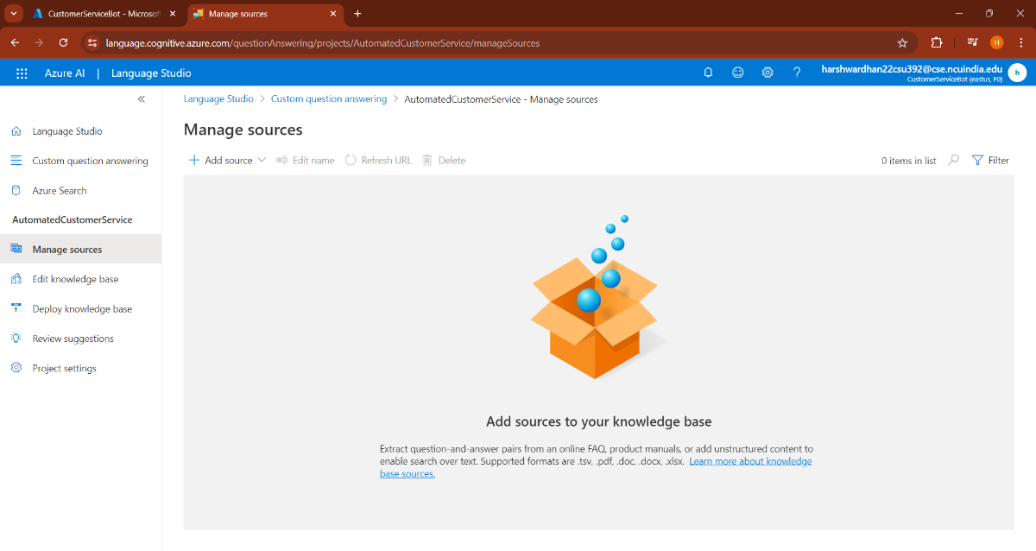

Figure 5.1.2: Adding Sources in Knowledge Base

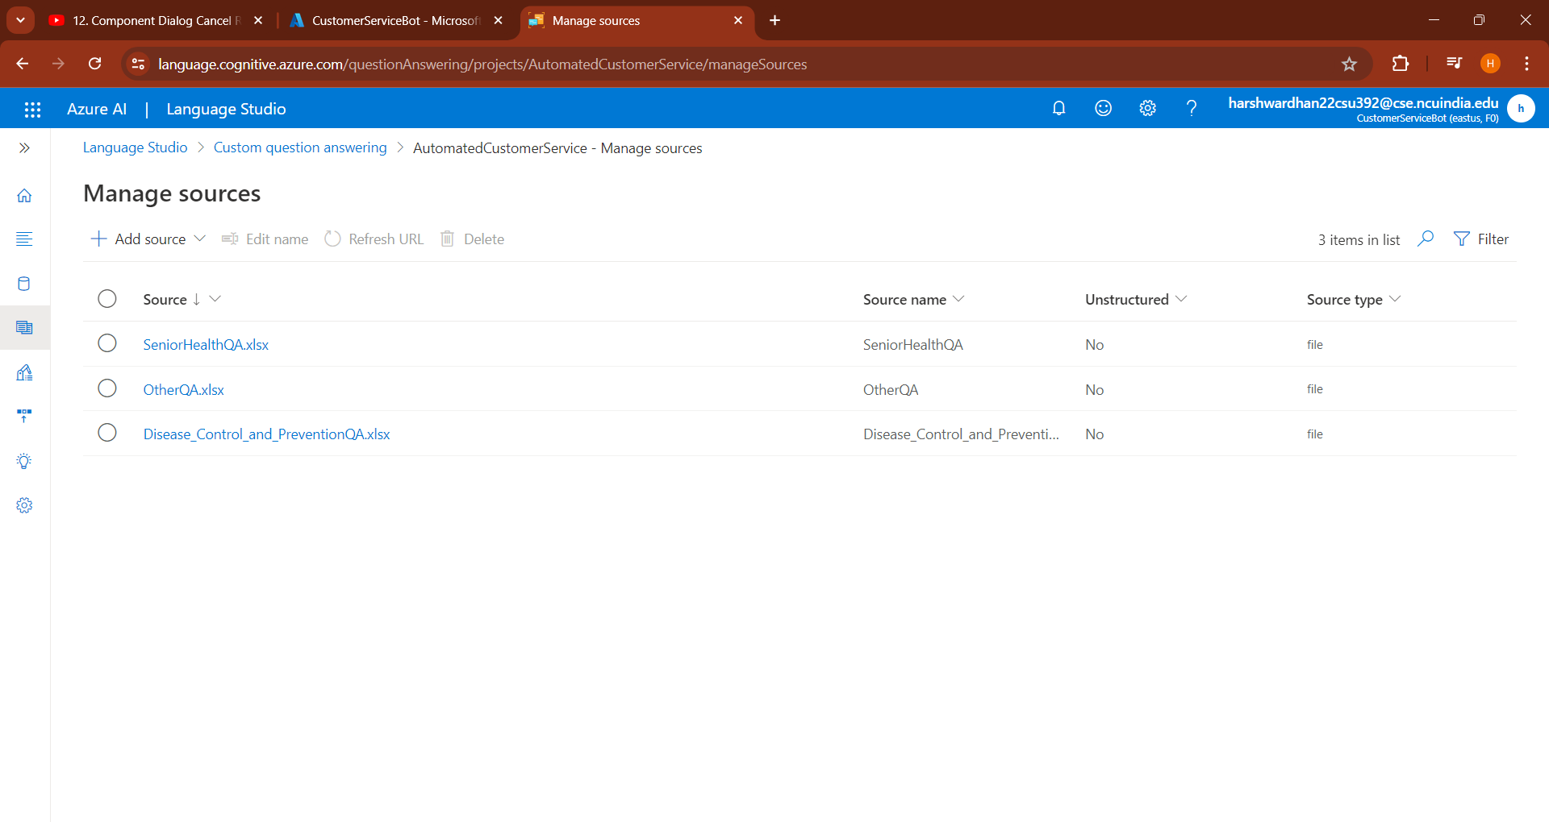

Figure 5.1.3: Editing and Testing Sources

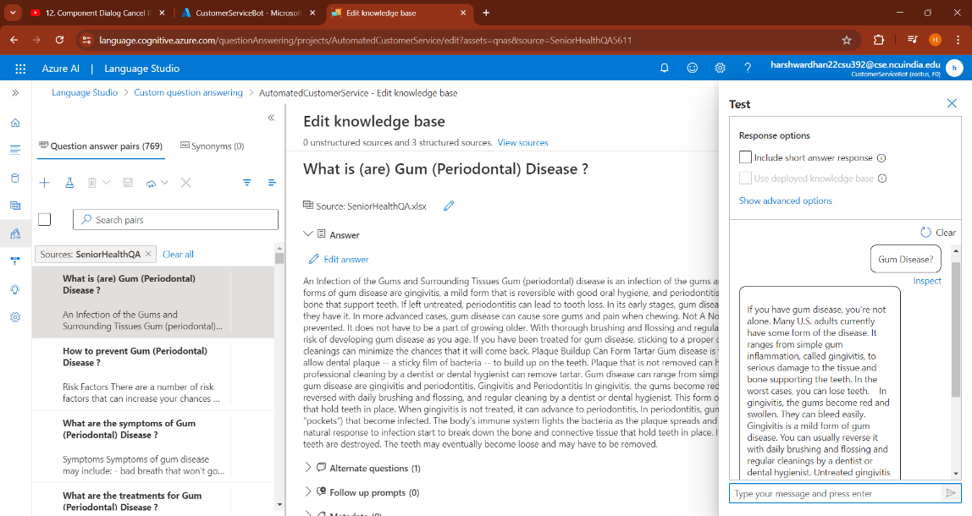

**5.2 Conversational Language Understanding**

Figure 5.2.1: Empty Schema

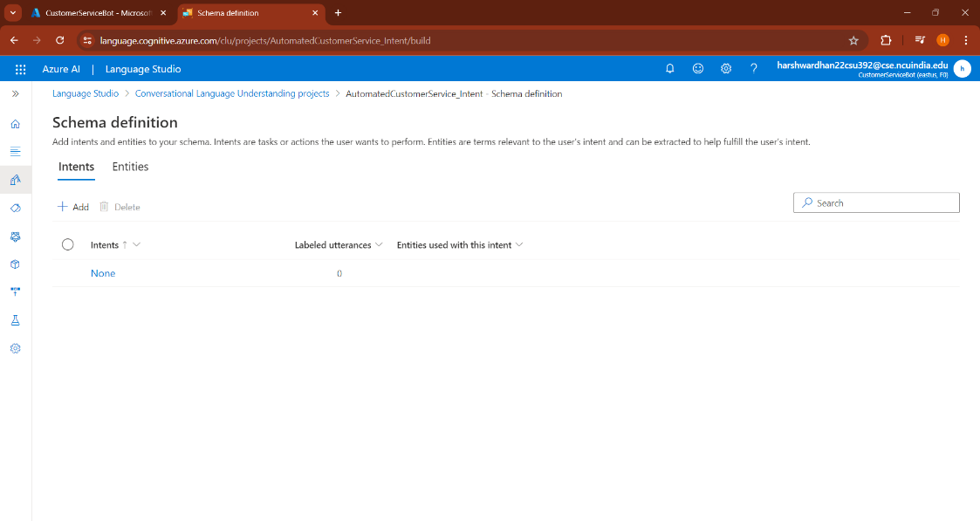

Figure 5.2.2: Adding Intents in the Schema

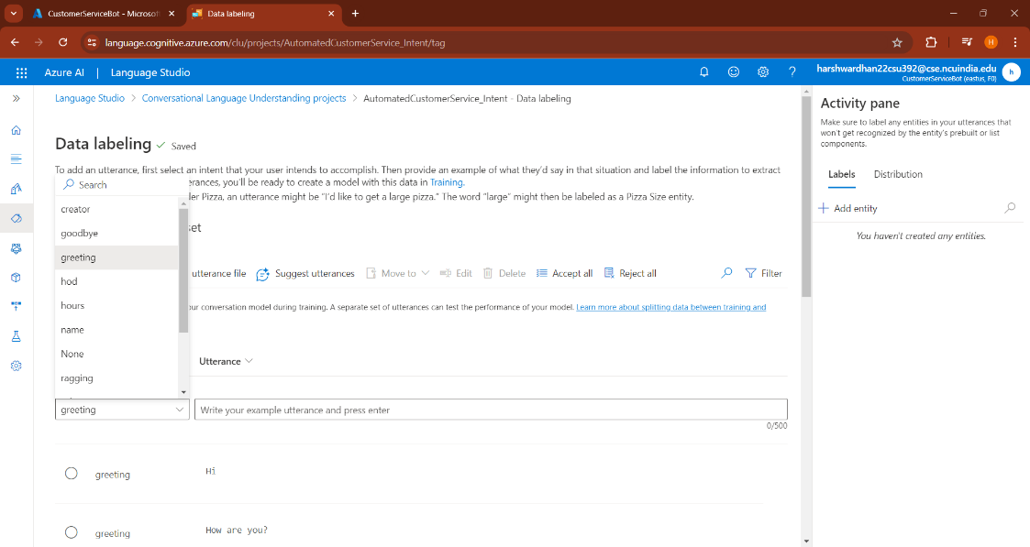

Figure 5.2.3: Training Model Part 1

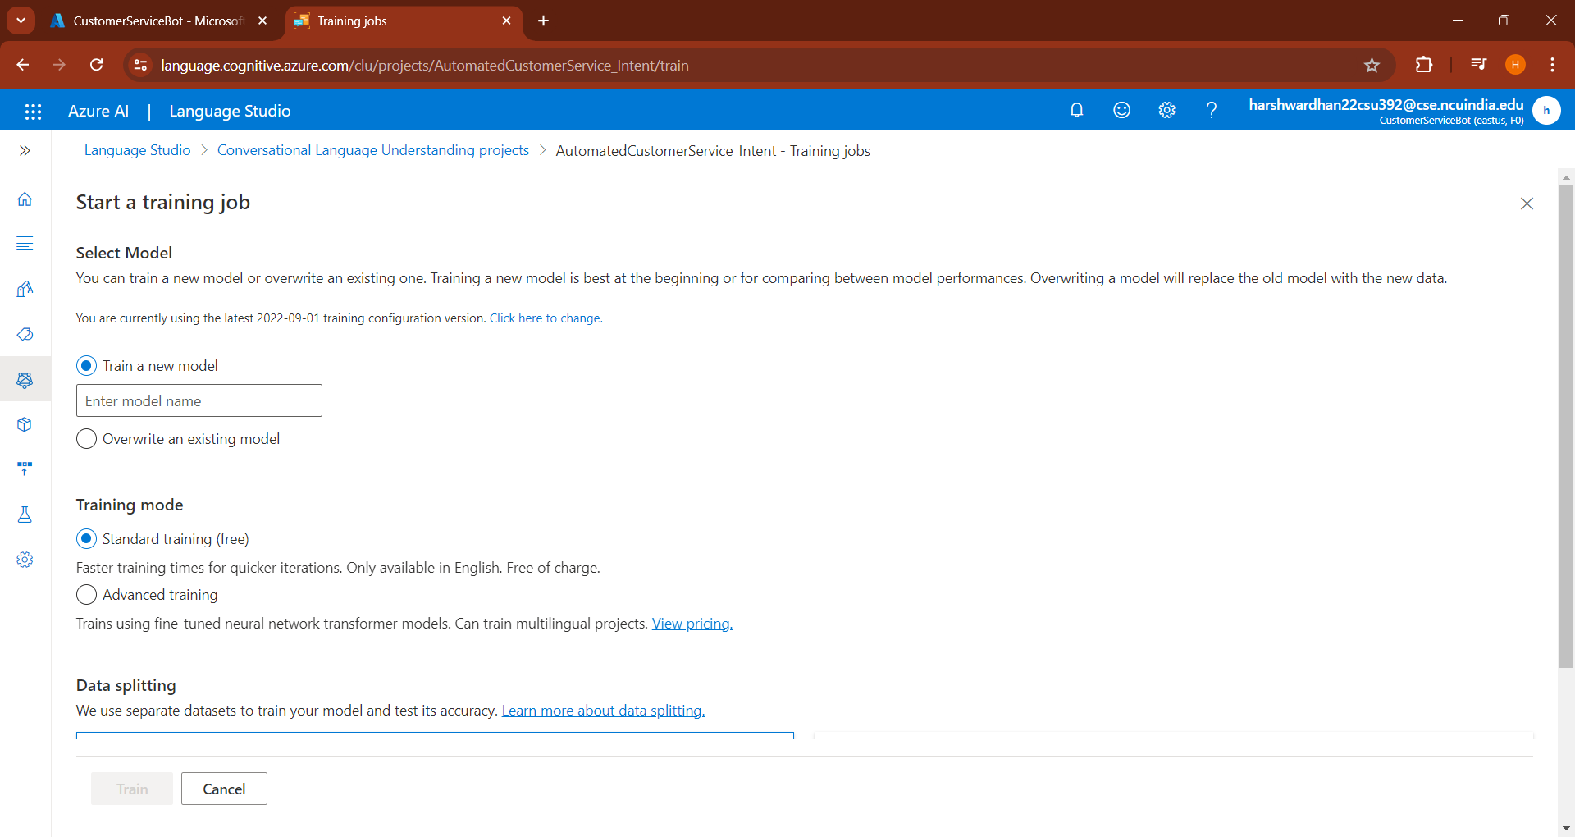

Figure 5.2.4: Training Model Part 2

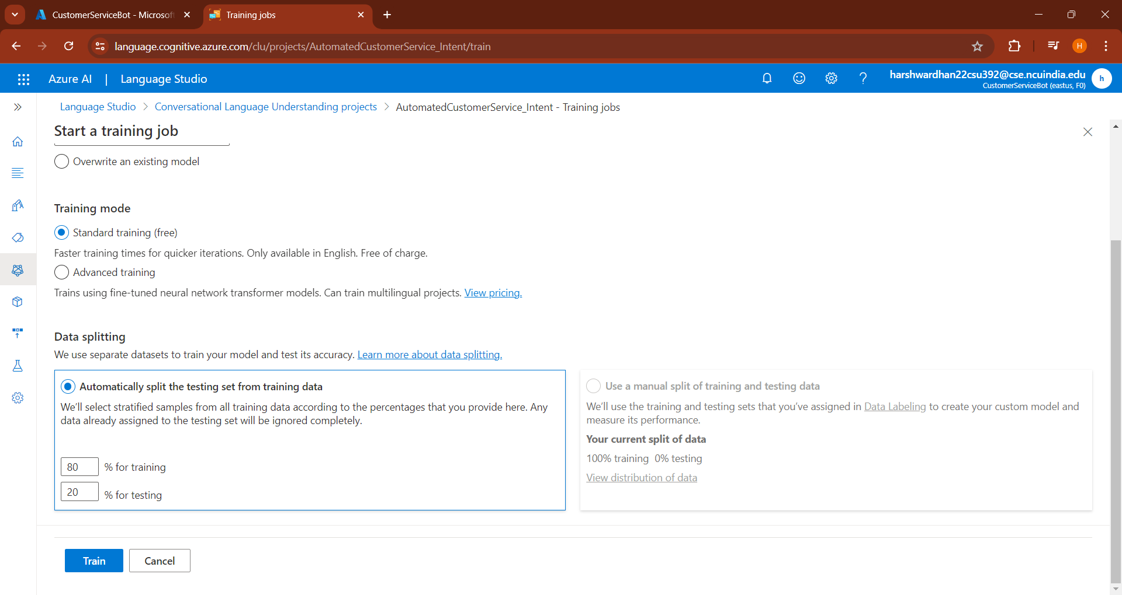

Figure 5.2.5: Model Performance Analysis

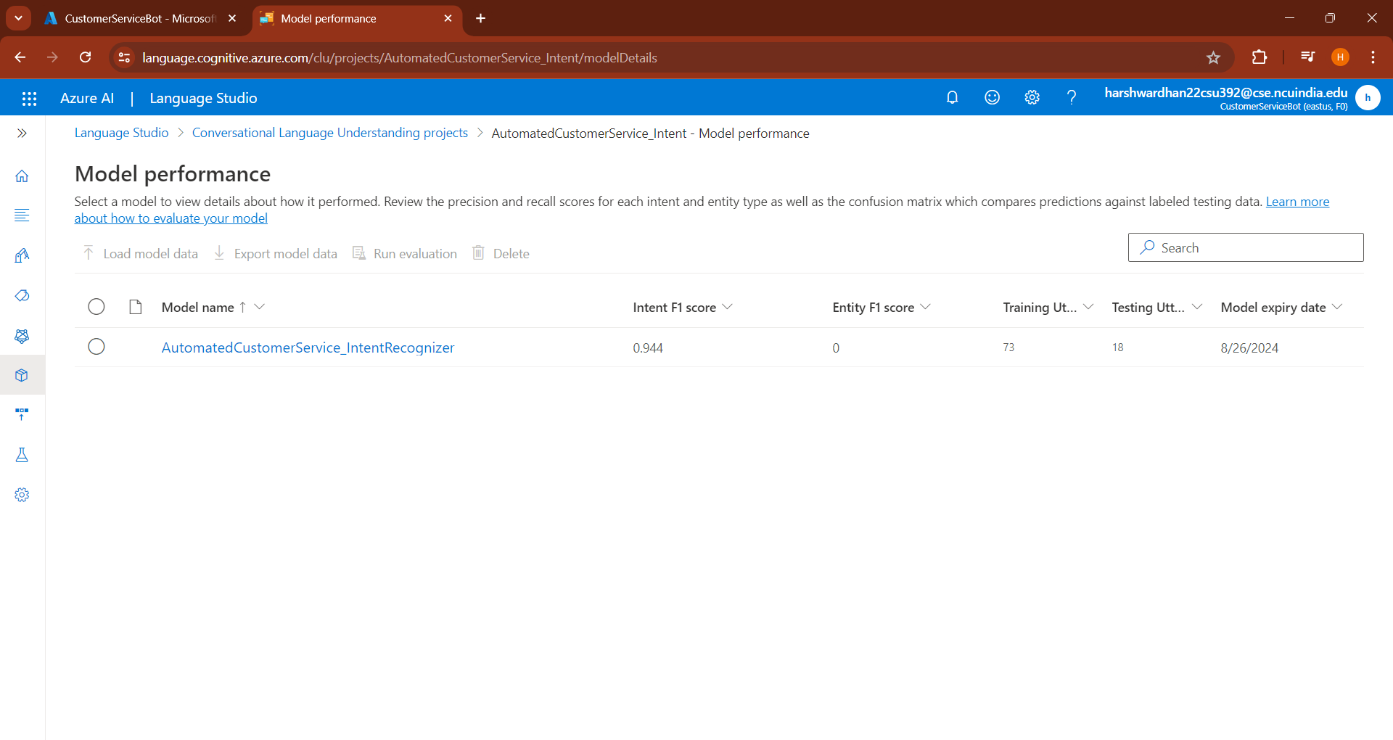

**5.3 Bot Framework Emulator (V4)**

Figure 5.3.1: Installing Dependencies for the Bot

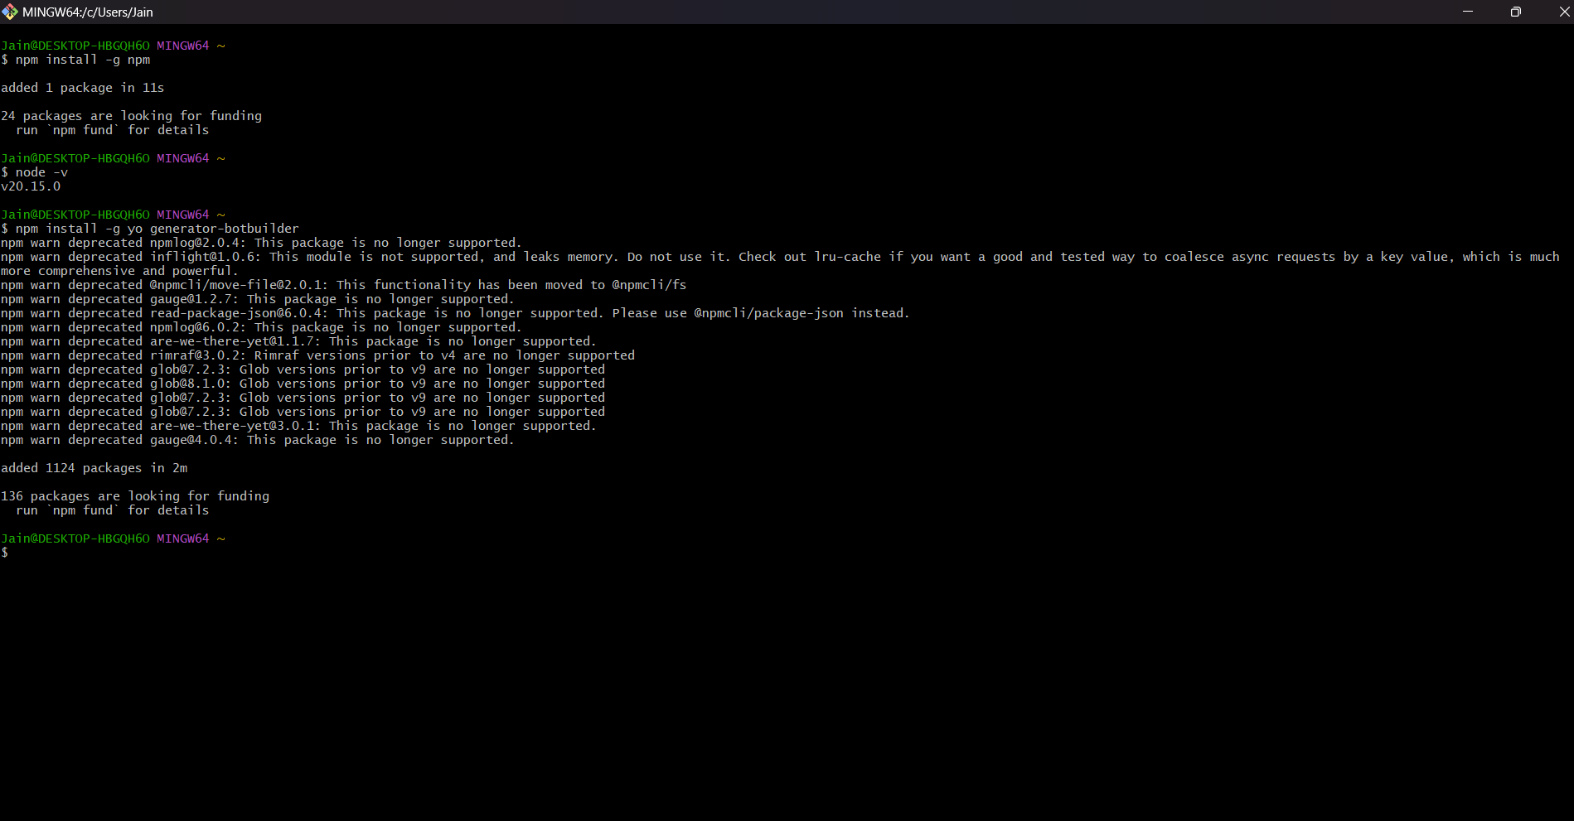

Figure 5.3.2: Configuring Medical Bot

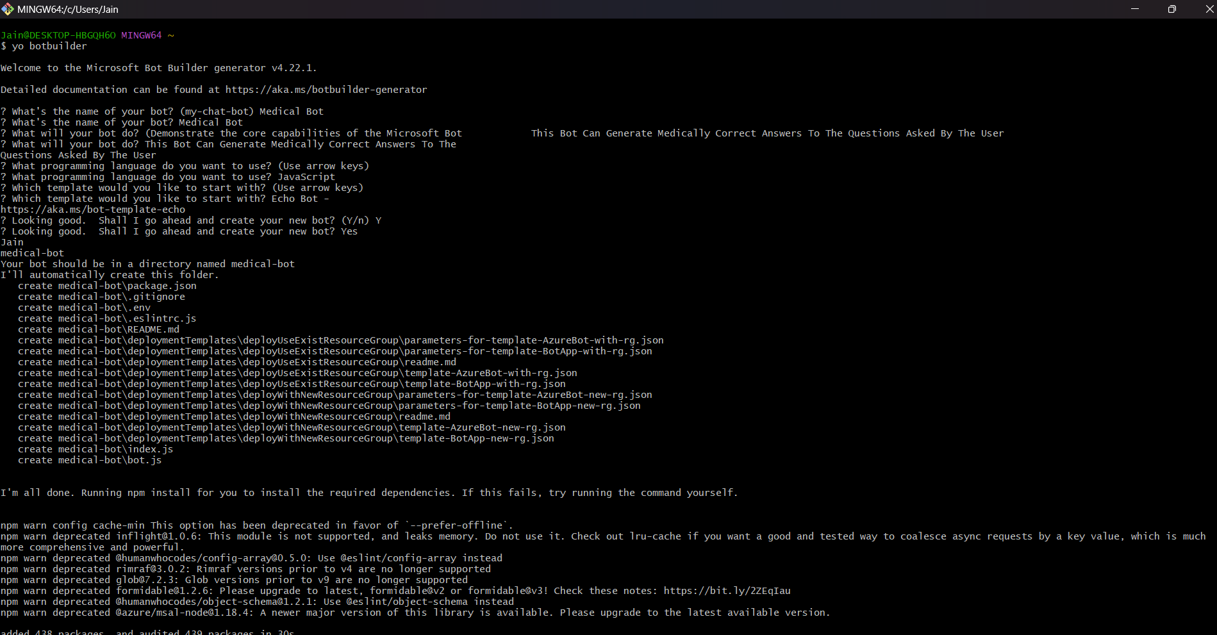

Figure 5.3.3: Done Finalizing the Medical Bot

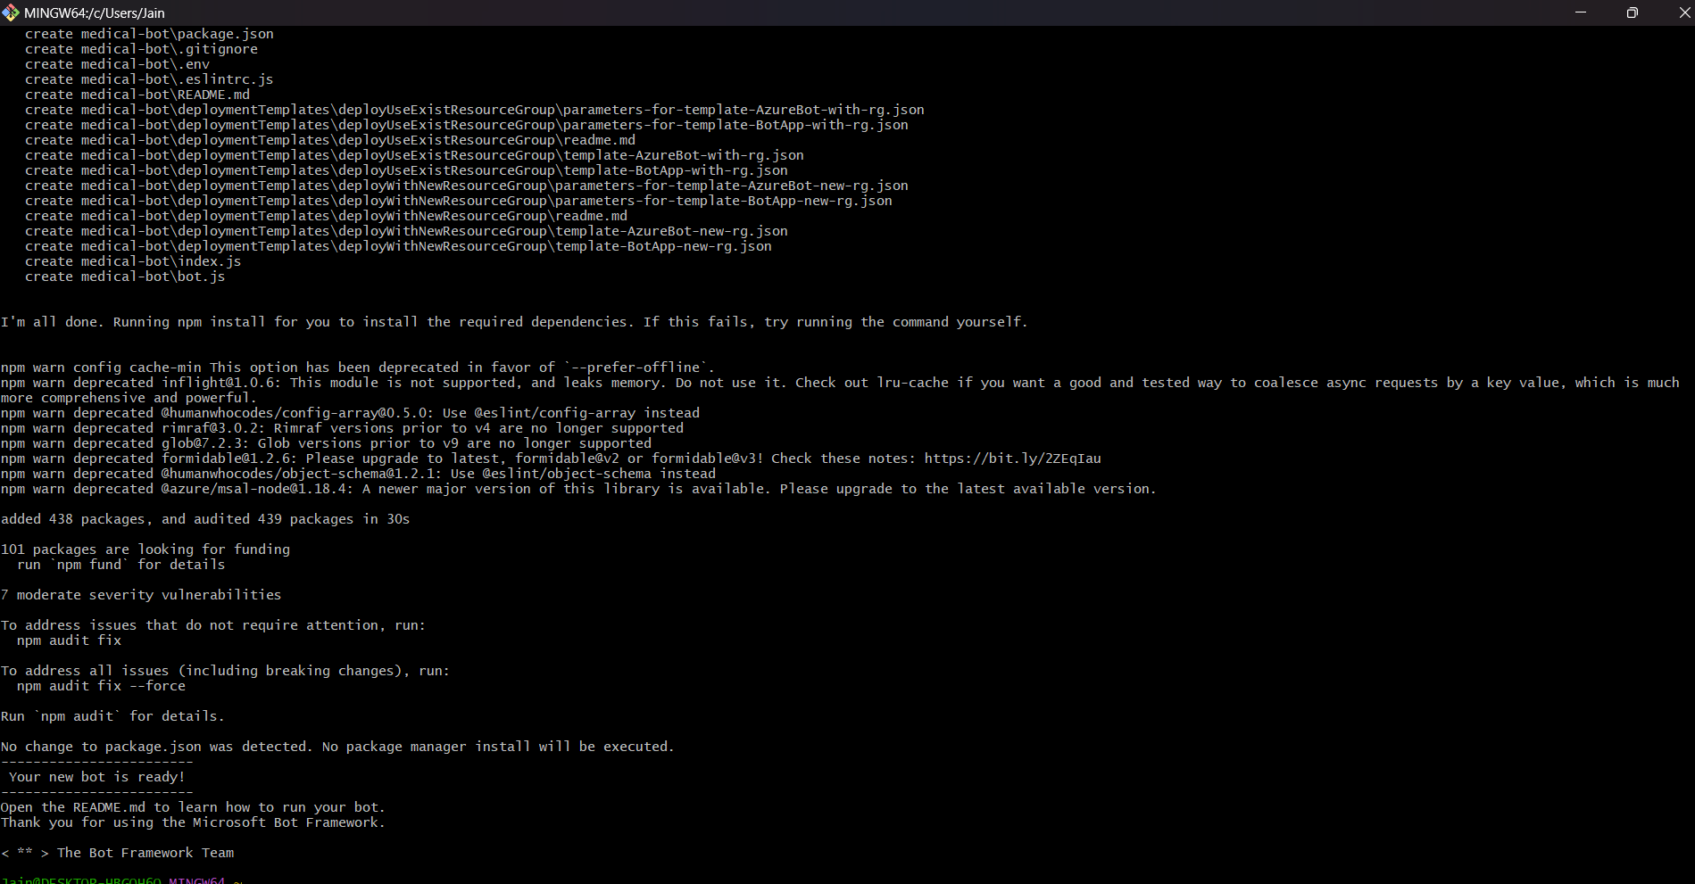

Figure 5.3.4: Snapshot of bot.js File

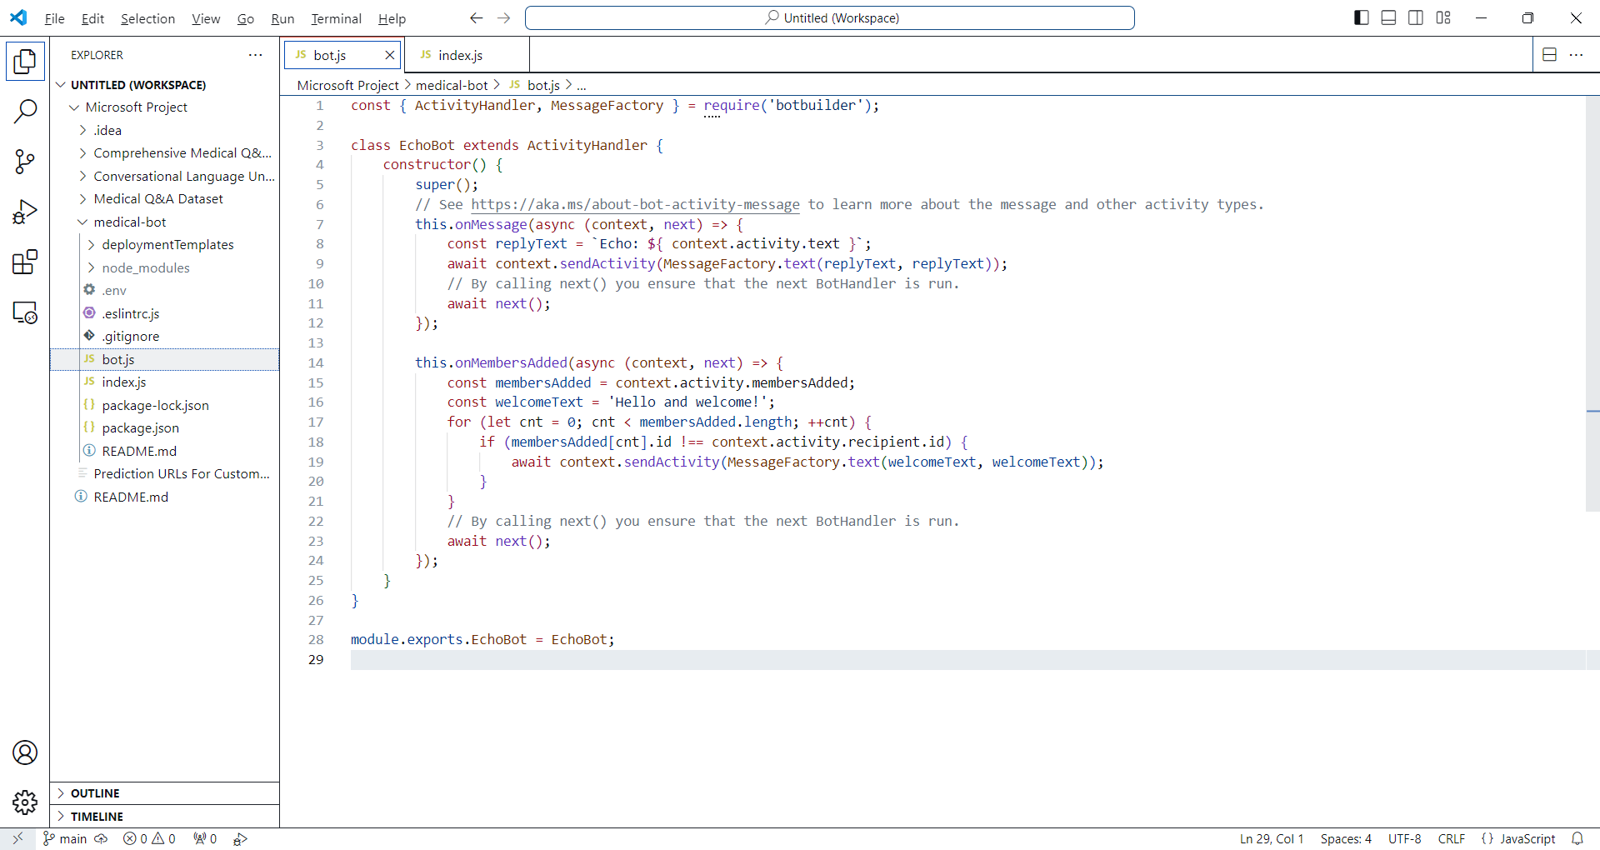

Figure 5.3.5: Snapshot of index.js File

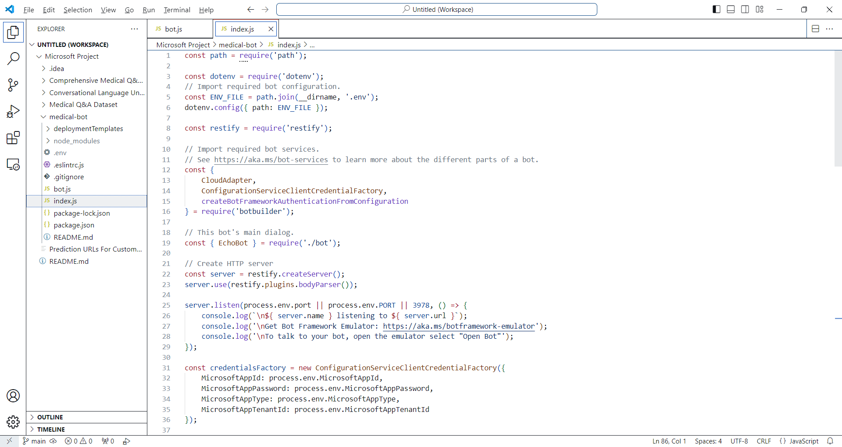

Figure 5.3.6: Creating a Bot in Bot Framework Emulator

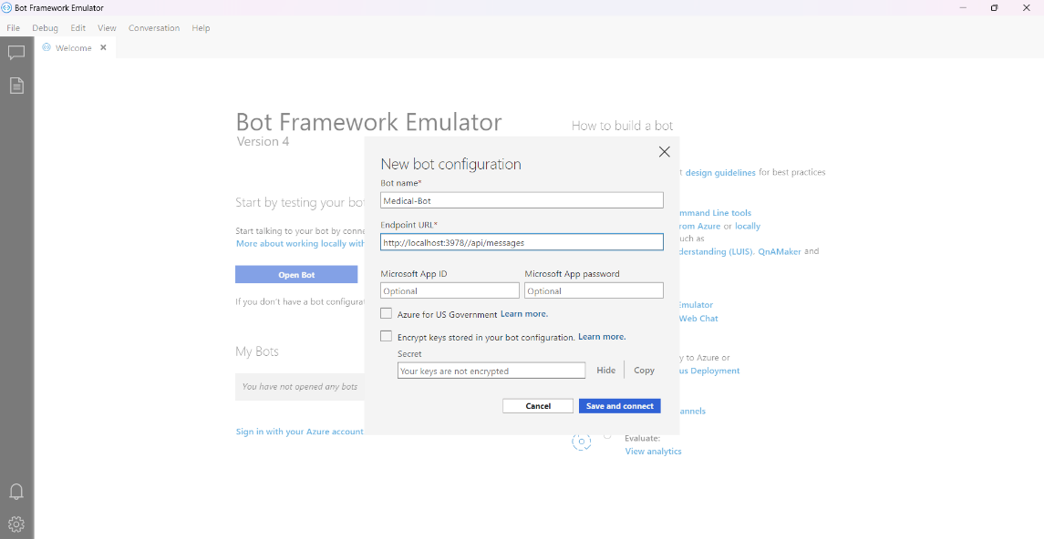

Figure 5.3.7: Saving Medical Bot File

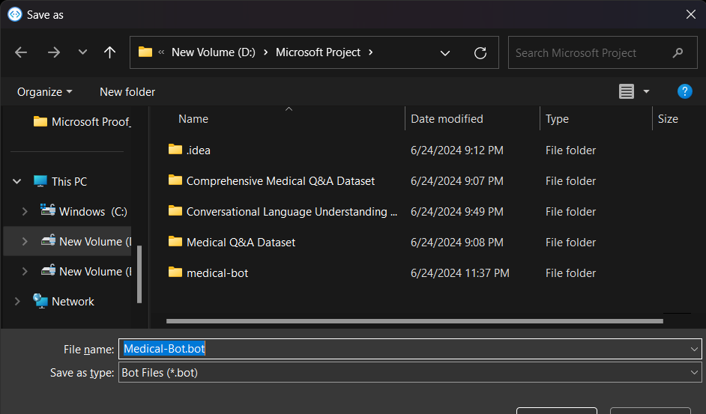

Figure 5.3.8: Testing the Saved Bot Model

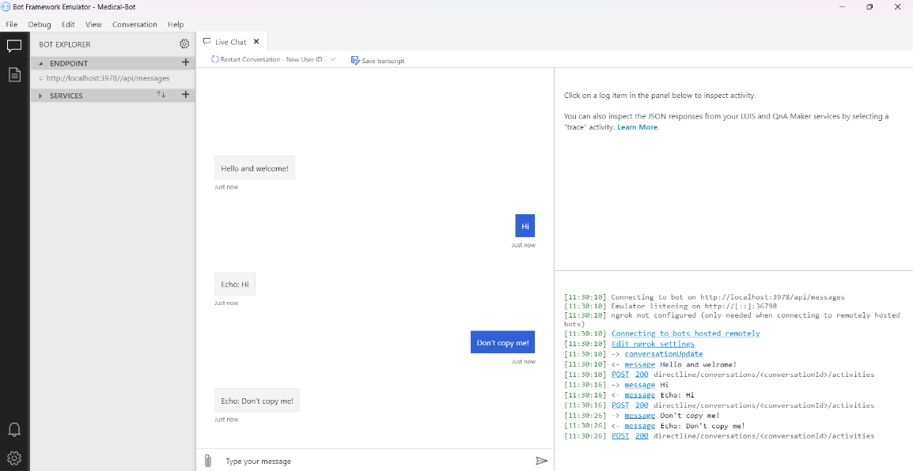

**6. ANALYSIS**

The training significantly advanced my understanding of AI and its applications within the engineering profession. It provided me with a blend of technical and non-technical skills that are essential for a career in AI and machine learning.

**6.1 Technical Skills Acquired**

During the training, I developed a deep understanding of AI model development and deployment. Working extensively with Azure’s suite of AI services, I learned how to:

* **Develop AI Models**: Using Azure Machine Learning Studio, I gained hands-on experience in creating, training, and deploying machine learning models. This involved working with no-code and low-code environments, making the process efficient and accessible.
* **Utilize Cognitive Services**: I became proficient in using Azure Cognitive Services, such as Computer Vision for image analysis, Custom Vision for image classification and object detection, Face API for facial recognition, and Form Recognizer for document processing.
* **Implement Conversational AI**: Through the development of a customer service system, I learned to use Custom Question Answering and Conversational Language Understanding services, enhancing my skills in natural language processing.

**6.2 Non-Technical Skills Acquired**

The training also emphasized the importance of non-technical skills:

* **Project Management**: I learned to manage project timelines, set milestones, and ensure timely completion of tasks. This included coordinating with peers and supervisors to maintain project alignment.
* **Teamwork**: The collaborative nature of the training allowed me to develop strong teamwork skills. I learned the value of clear communication, cooperation, and mutual support in achieving project goals.
* **Problem-Solving**: The iterative process of testing and debugging AI models honed my problem-solving abilities. I learned to approach challenges methodically and find effective solutions.

**6.3 Organizational Structure and Team Dynamics**

The organization was structured with clear roles and responsibilities, ensuring that all aspects of the syllabus were covered comprehensively. Individuals worked together seamlessly, with technical employees, including trainers, being highly informative and responsive. This cooperative environment facilitated a productive learning experience and ensured that any issues or questions were promptly addressed.

**6.4 Company Initiatives**

One notable initiative observed during the training was the reimbursement of training costs upon passing the exam. This incentive motivated thorough preparation and dedication, as the financial reward provided an additional layer of motivation to succeed.

**6.5 Performance Analysis**

Throughout the training, I demonstrated consistent dedication and focus, which led to passing the exam on my first attempt. My primary strengths included:

* **Solid Understanding of AI Concepts**: I developed a strong grasp of computer vision algorithms and the overall AI concepts taught during the training.
* **Application of Knowledge**: I successfully applied theoretical knowledge to practical scenarios, developing and deploying AI models that met the project requirements.

**6.6 Areas for Improvement**

While the training was largely successful, I identified generative AI as an area for improvement. Although I gained a good understanding of various AI technologies, generative AI remained a challenging concept. In the future, I would focus more on exploring and understanding generative AI models and their applications.

**7. CONCLUSION**

The summer training program was immensely valuable in advancing both my technical and organizational understanding of the engineering profession. It provided a comprehensive learning experience that significantly enriched my knowledge and skills in AI and machine learning.

**7.1 Advancement in Technical Understanding**

Through hands-on experience with Azure AI services, I gained a deep understanding of various AI technologies and their applications. The training allowed me to:

* **Develop and Deploy AI Models**: I learned the complete lifecycle of AI model development, from data preparation and model training to testing and deployment. Working with Azure Machine Learning Studio and Cognitive Services, I was able to build sophisticated AI models that address real-world problems.
* **Practical Application of AI Technologies**: The practical nature of the training enabled me to apply theoretical concepts to real-world scenarios. This practical exposure was crucial in solidifying my understanding of AI and machine learning principles.
* **Technical Problem-Solving**: The training also honed my problem-solving skills, as I encountered and overcame various technical challenges while developing AI solutions.

**7.2 Enhancement of Organizational Skills**

The training also advanced my organizational understanding:

* **Project Management**: I learned to manage projects effectively, ensuring timely completion of tasks and meeting project goals. This included setting milestones, coordinating with team members, and managing resources efficiently.
* **Teamwork and Collaboration**: Working in a team environment taught me the importance of collaboration and clear communication. I experienced firsthand how effective teamwork can drive the success of engineering projects.

**7.3 Benefits Acquired from the Training**

The training provided several benefits that will be valuable in my future career:

* **Improved AI Skills**: I developed a strong foundation in AI technologies, particularly in areas such as computer vision, natural language processing, and conversational AI.
* **Enhanced Project Management Capabilities**: The experience of managing and executing projects from start to finish improved my organizational and project management skills.
* **Increased Confidence and Motivation**: Successfully completing the training and passing the exam on the first attempt boosted my confidence in my abilities and motivated me to continue learning and growing in the field of AI.

**7.4 Enrichment of Knowledge**

The training enriched my knowledge by providing exposure to cutting-edge AI technologies and real-world applications. It highlighted the importance of continuous learning and staying updated with advancements in AI.

**7.5 Areas for Further Improvement**

While the training was comprehensive, it also revealed areas for further improvement:

* **Generative AI**: I identified generative AI as an area where I need to deepen my understanding. Future training programs could include more focused content on advanced AI topics like generative models.
* **Practical Applications**: Increasing the emphasis on practical applications and real-world case studies would enhance the learning experience, providing more opportunities to apply theoretical knowledge to practical scenarios.

**7.6 Suggestions for Improvement of the Training Program**

Based on my experience, I suggest the following improvements for the training program:

* **Focus on Advanced AI Topics**: Incorporating more advanced topics, such as generative AI, would provide a more comprehensive understanding of the field.
* **Emphasis on Practical Applications**: Including more hands-on projects and real-world case studies would enhance practical learning and better prepare trainees for industry challenges.

**8. BIBLIOGRAPHY**

1) P. Kumar, "Customer Review Dataset," Kaggle, 2020. [Online]. Available: https://www.kaggle.com/datasets/parve05/customer-review-dataset. [Accessed: Jun. 06, 2024].

2) S. Kumar, "Customer Support Ticket Dataset," Kaggle, 2020. [Online]. Available: https://www.kaggle.com/datasets/suraj520/customer-support-ticket-dataset. [Accessed: Jun. 06, 2024].

3) TheDevastator, "Comprehensive Medical Q&A Dataset," Kaggle, 2020. [Online]. Available: https://www.kaggle.com/datasets/thedevastator/comprehensive-medical-q-a-dataset. [Accessed: Jun. 06, 2024].

4) F. Ndlovu, "Tutorial: Azure QnA Maker Chatbot for Students," Medium, 2020. [Online]. Available: https://faniendlovu.medium.com/tutorial-azure-qna-maker-chatbot-for-students-1565ae327781. [Accessed: Jun. 06, 2024].

5) G. Valdenebro, "Cancer Q&A Dataset," Kaggle, 2020. [Online]. Available: https://www.kaggle.com/datasets/gvaldenebro/cancer-q-and-a-dataset. [Accessed: Jun. 06, 2024].

6) Kaggle, "Medical Q&A Dataset," Kaggle, 2020. [Online]. Available: https://www.kaggle.com/search?q=Medical+Q%26A+Dataset+datasetFileTypes%3Axlsx+datasetFileTypes%3Acsv. [Accessed: Jun. 07, 2024].

7) Kaggle, "Discussion: General," Kaggle, 2020. [Online]. Available: https://www.kaggle.com/discussions/general/22274. [Accessed: Jun. 07, 2024].

8) N. Vaghani, "Chatbot Dataset," Kaggle, 2020. [Online]. Available: https://www.kaggle.com/datasets/niraliivaghani/chatbot-dataset. [Accessed: Jun. 07, 2024].

9) Simplilearn, "What is Azure? Introduction to Microsoft Azure," YouTube, Sep. 28, 2020. [Online]. Available: https://www.youtube.com/watch?v=7e0WfpDatoQ. [Accessed: Jun. 07, 2024].

10) Edureka, "Azure Tutorial for Beginners," YouTube, Nov. 10, 2020. [Online]. Available: https://www.youtube.com/watch?v=URtriuC2Hfo&list=PLDJM81OaKKZEYBt11qn7fLca_67jORwJp&index=4. [Accessed: Jun. 10, 2024].

11) Intellipaat, "Microsoft Azure Tutorial," YouTube, Nov. 12, 2020. [Online]. Available: https://www.youtube.com/watch?v=beYY-mliZmA&list=PLbmEvpJ6NLH-RDwkA1-BJd-Z5GqXOQmN0&index=13. [Accessed: Jun. 10, 2024].

12) Edureka, "Azure Machine Learning Tutorial," YouTube, Nov. 20, 2020. [Online]. Available: https://www.youtube.com/watch?v=gnVLSx3Q9BQ&list=PLDJM81OaKKZEYBt11qn7fLca_67jORwJp&index=7. [Accessed: Jun. 15, 2024].

13) Simplilearn, "Azure Fundamentals Certification," YouTube, Nov. 25, 2020. [Online]. Available: https://www.youtube.com/watch?v=N-INuOOGVis&list=PLbmEvpJ6NLH-RDwkA1-BJd-Z5GqXOQmN0&index=12. [Accessed: Jun. 20, 2024].

**9. APPENDIX**

**9.1 Introduction to The Hosting Firm**

The training was hosted at **The NorthCap University**, a leading institution renowned for its focus on technology and engineering education. The university provided an ideal environment for AI and machine learning training, offering state-of-the-art resources and facilities. The institution's **collaboration with Microsoft** allowed us to work extensively with Microsoft Azure, a premier cloud computing platform essential for developing and managing AI applications.

**9.2 Management and Administrative Structure**

The training program was structured with clear roles and responsibilities, ensuring that the project was conducted efficiently and effectively. The key individuals involved included:

* **Training Supervisor**: Responsible for overseeing the project, providing guidance, and ensuring alignment with the training objectives.
* **Technical Lead**: Offered expertise in Azure services and assisted in resolving technical challenges.
* **Peer Group**: Consisted of fellow trainees who collaborated on project tasks, shared knowledge, and provided feedback.
* **Azure Support Team**: Provided technical support for Microsoft Azure services, ensuring smooth operation and troubleshooting any issues.

This structured approach fostered a collaborative environment, critical for the successful completion of the project.

**9.3 Sample Plans or Drawings**

This section includes diagrams and plans that illustrate the architecture and workflow of the AI-based customer service system developed during the training. These visual aids include:

* **System Architecture Diagram**: Showcasing the integration of various Azure services such as Azure Machine Learning, Cognitive Services, and Custom Vision.
* **Data Flow Diagram**: Mapping the process of data collection, model training, and deployment within the Azure environment.
* **User Interaction Flowchart**: Detailing how customer inquiries are processed and responded to by the automated system.

These diagrams provide a comprehensive understanding of the technical framework and processes involved in the project.

**9.4 Technical Documents and Literature**

This section compiles technical documentation and literature that supported the project, including:

* **Azure Machine Learning Documentation:** Guides on creating, training, and deploying models using Azure's no-code and low-code environments.
* **Cognitive Services API Reference**: Instructions on utilizing Azure Cognitive Services for tasks such as image analysis, natural language processing, and more.
* **AI Deployment Best Practices**: Articles and white papers on deploying AI models in cloud environments, focusing on scalability, security, and efficiency.

These documents were instrumental in guiding the technical aspects of the project.

**9.5 Design and Calculation Sheets**

Design and calculation sheets provided here lay the groundwork for the AI models developed, including:

* **Model Design Sheets**: Detailing the architecture of machine learning models, including feature selection, algorithm choice, and parameter settings.
* **Performance Metrics Calculations**: Demonstrating key performance indicators such as accuracy, precision, and recall for the models.
* **Resource Allocation Sheets**: Outlining the computation resources required, such as CPU, GPU, memory, and the associated costs of running models on Azure.

These sheets highlight the analytical approach taken during the model development process.

**9.6 Project Daily Task**

This section provides a detailed log of the daily tasks performed throughout the training.

|  |  |  |
| --- | --- | --- |
| 9.6 Project Daily Task | | |
| Date | **Day** | **Work** |
| June 12, 2024 | **Wednesday** | **Project assigned - Automated Customer Services using Azure Conversational AI Tools; Initial setup and study of project requirements.** |
| June 13, 2024 – June 16, 2024 | **Thursday – Sunday** | **Explored potential datasets for Azure services. Decided to create a Medical Bot aimed at providing medically accurate answers to users automatically.** |
| June 17, 2024 | **Monday** | **Initial GitHub commit; Created repository on GitHub. Set up development environments such as Bot Builder, Bot Framework, and other tools necessary for the project.** |
| June 18, 2024 – June 23, 2024 | **Tuesday - Sunday** | **Studied Azure Conversational Services and discussed the use of Azure for Custom Question Answering and Conversation Language Understanding.** |
| June 24, 2024 | **Monday** | **Added datasets, modified CancerQA dataset, and uploaded the Conversational Language Understanding dataset to Azure. Added prediction URLs for the services.** |
| June 25, 2024 | **Tuesday** | **Added the Medical Bot folder, renamed files, updated scripts to work with prediction URLs, and improved the bot's response accuracy. Updated README and cleaned up datasets.** |
| June 26, 2024 – June 28, 2024 | **Wednesday - Friday** | **Fixed minor errors in the code.** |

|  |  |  |
| --- | --- | --- |
| June 29, 2024 | Saturday | Added .gitignore to remove the .idea folder, improved interactivity of index.js and medicalbot.js, and updated the Conversational Language Understanding dataset. |
| June 30, 2024 | **Sunday** | **Updated README with final step-by-step instructions for executing the index.js file.** |
| July 1, 2024 | **Monday** | **Finalized the project.** |

**10. PROJECT AT A GLANCE**

Figure 10.1: Final Snapshot of medicalbot.js File

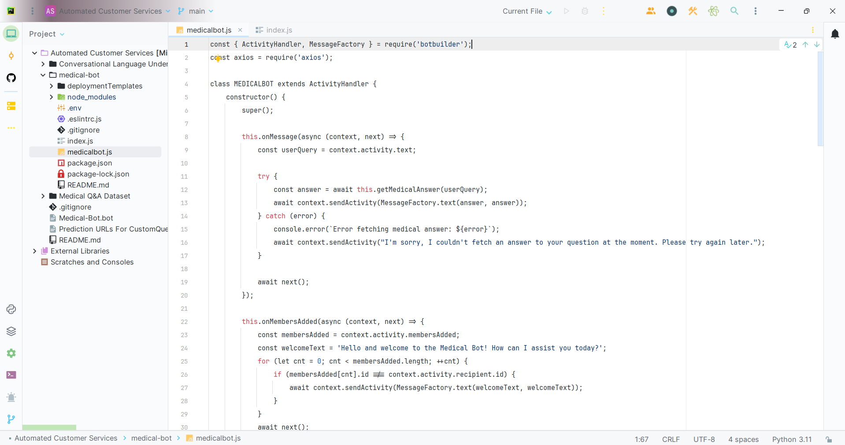

Figure 10.2: Final Snapshot of index.js File

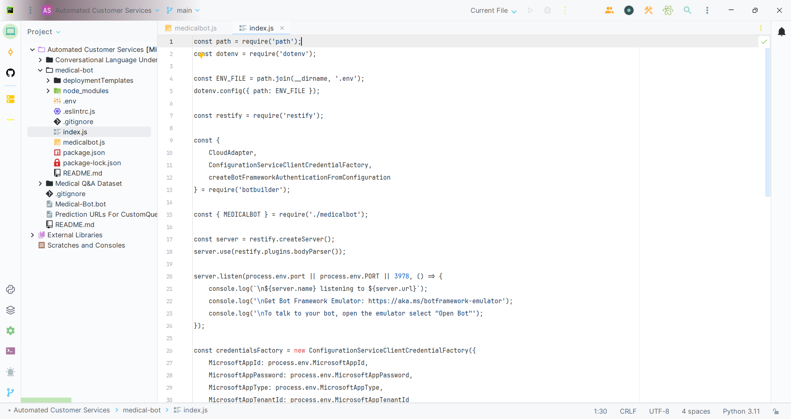

Figure 10.3: Executing the index.js File

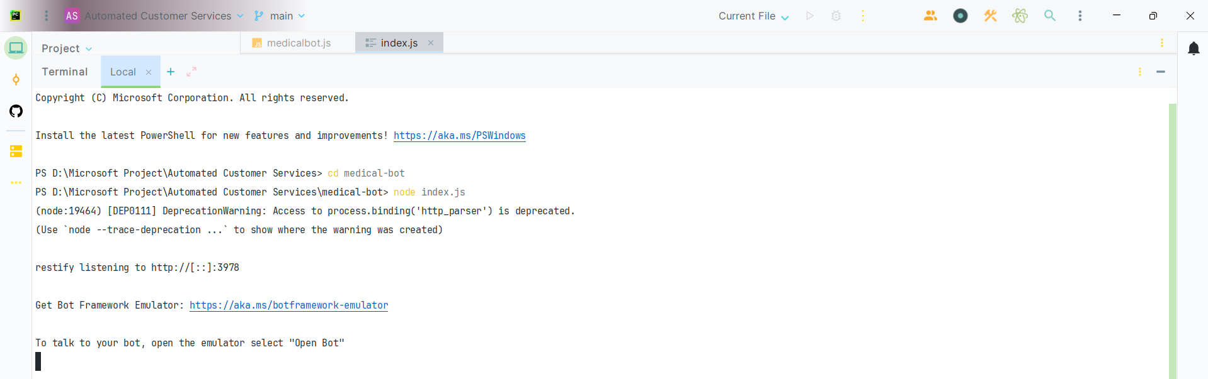

Figure 10.4: Running the Bot Framework Emulator

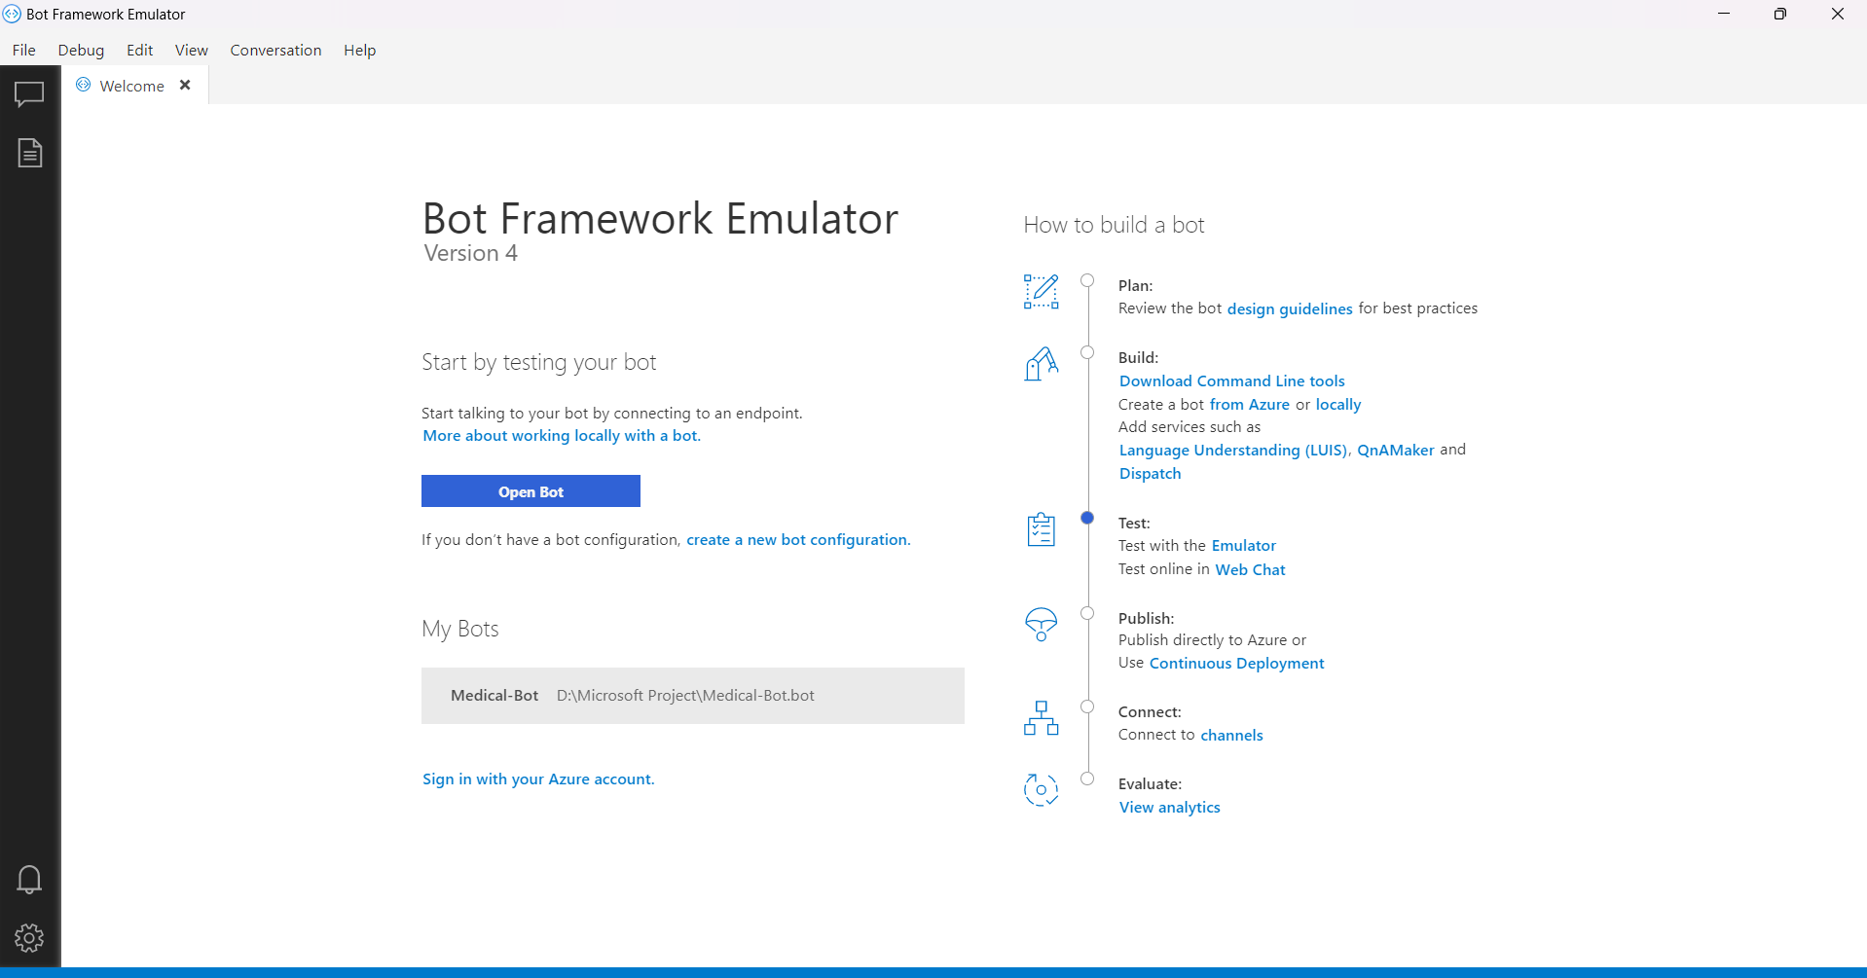

Figure 10.5: Connecting the Saved Medical Bot

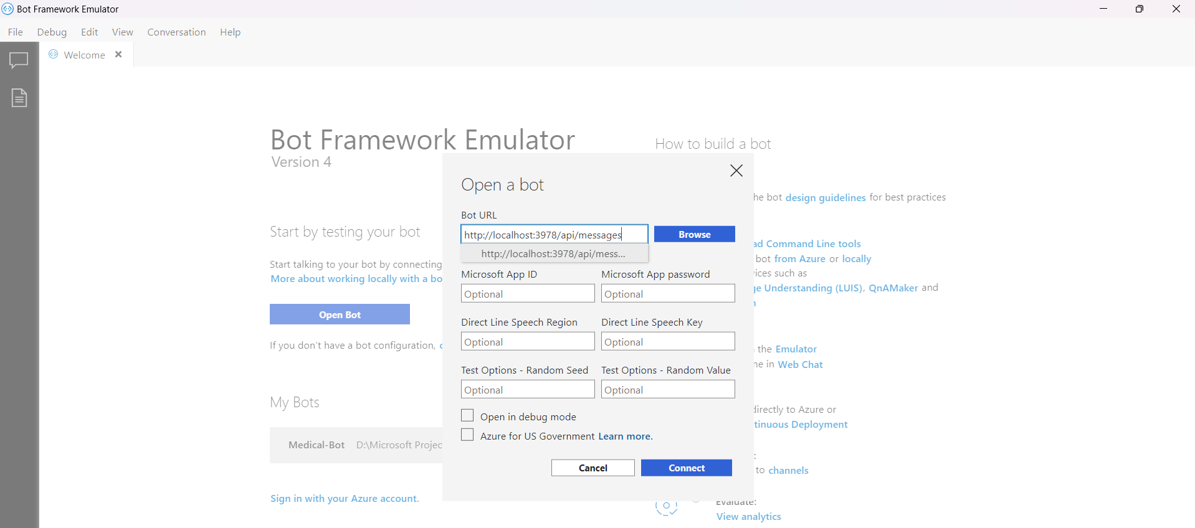

Figure 10.5: Testing the Live Medical Bot

